QS4: STAR LAWS (Shedding Light on Astronomy) Episode IV: What is your Latitude and Longitude?
Name: __________________________________
- Which reservoir is in grid squares C4 and D4? ___________________
- Which mountain is located in C7? _______________
- In which grid square is Wombelano Falls? ________
- In which grid square is Island Creek Picnic Area? ________
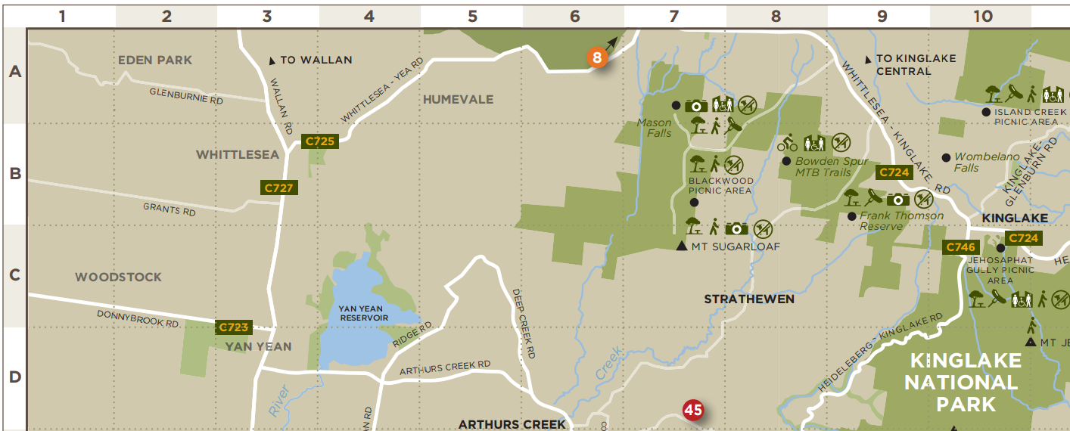

City | Latitude
Tapalucha | 145°E
Minneapolis | 74W
Belgrade | 24E
City | Longitude
Wolf Bay | 145°E
Memphis | 74W
Termoli | 24E
- Use the lines of longitude and the lines of latitude marked on these pictures of the Earth to fill in the tables below. Include the direction (N, S, E, or W).
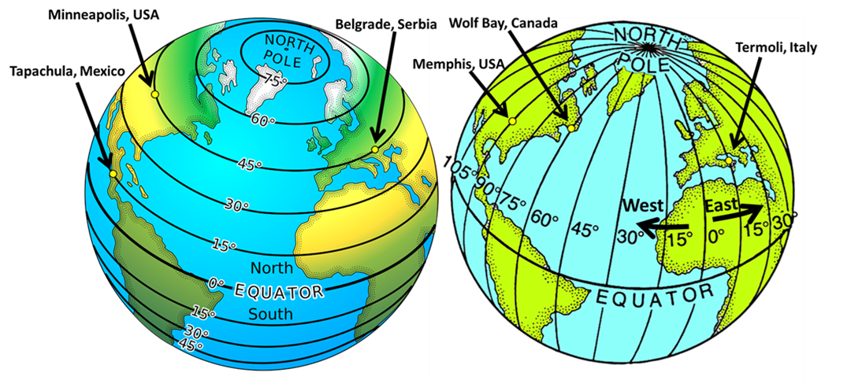

- Lines of longitude are also called ________________________.
- Lines of latitude are also called _______________________.
- The North Pole has a latitude of _______________ and the South Pole has a latitude of ________________.

- (a) Use the map below to find the latitude and longitude of Melbourne, Seattle, Athens, and Lima.
(b) Use the co-ordinates in the table on the right to mark in the location of Perth, Cairns, Montevideo, and Anchorage.
Remember: Latitude: how far from the equator (N or S); Longitude: how far from the prime meridian (W or E)
City | Latitude | Longitude
Melbourne | 38°S | 145°E
Seattle | 41N | 74W
Athens | 38N | 24E
Lima | 34S | 18E
City | Latitude | Longitude
Perth | 32°S | 116°E
Tokyo | 36°N | 140°E
Concepcion | 37°S | 73°W
Anchorage | 61°N | 150°W

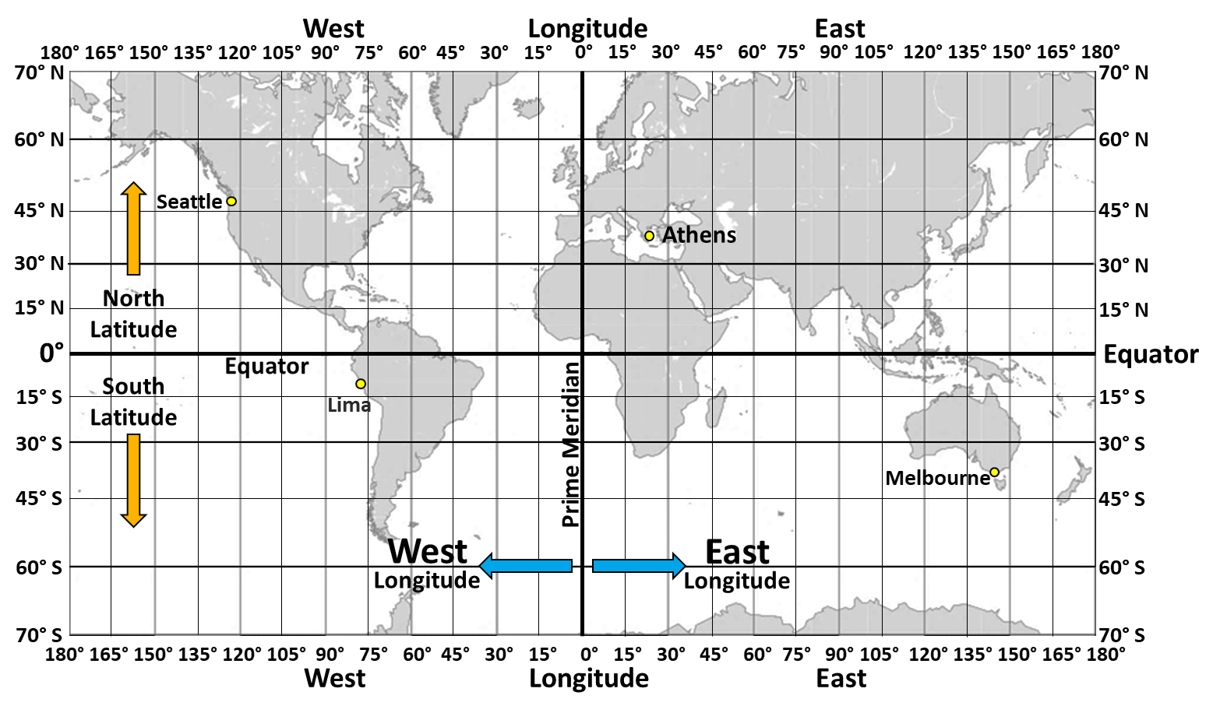
- If it isn’t already marked, place a mark on the map of your city or town and determine its latitude and longitude.
City or town: ____________________________; Latitude: _______________; Longitude: _______________
- What can be said about the length of all lines of longitude? __________________________________________
____________________________________________________________________________________________
- The equator is the longest line of __________________.
- Lines of latitude get ________________ (shorter or longer) and you get further from the equator.

- How much distance (in kilometres) is 1 degree of latitude? __________ kilometres
- If you start in Anchorage and you drive 222 km to the north, what will your latitude be? ____________
- If you are in Perth, and you drive 999 km to the north, what will your latitude be? ______________
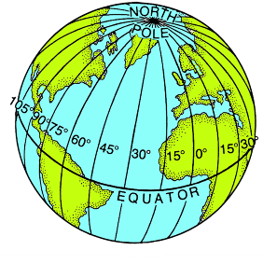
- How much distance (in kilometres) is 1 degree of longitude at the equator? ______________
- What happens to the distance between each degree of longitude as you get further from the equator? ________________________________________________________
_______________________________________________________________________
_______________________________________________________________________
19. 1 degree of latitude = ____________km
20. 0.1 degrees of latitude = ____________km
21. 0.01 degrees of latitude = ____________km = ______________ metres
22. 0.001 degrees of latitude = ______________metres
23. 0.000 1 degrees of latitude = ____________metres
24. 0.000 01 degrees of latitude = ____________metres
25. 0.000 001 degrees of latitude = ____________metres
and so a co-ordinate expressed to 6 decimal places gives an accuracy of about _____________ centimetres

